ICS-JCS 2023 session programme
Japan Continence Society (JCS) 2023 Meeting
Date: 7-9th September, 2023
Venue: Keisei Hotel Miramare, Chiba, Japan (35 min from Narita International Airport, Chiba; 35 min from central Tokyo)
Chair: Ryuji Sakakibara, Neurology, Sakura Medical Center, Toho University
Vice-Chair: Noritoshi Sekido, Urology, Ohashi Medical Center, Toho University
This is the 30th anniversary of JCS!
Main Theme for the Meeting:
Neurogenic Lower Urinary Tract Dysfunction revisited!
～Patient-centered Approach from Bladder to Brain～
The 3-day sessions include molecular biology relevant to the lower urinary tract, pharmacology, physiology, medical technologies, brain diseases, spinal cord diseases, peripheral neuropathies, LUT & neuro-imaging, prostate hyperplasia, stress urinary incontinence, pelvic organ prolapse, interstitial cystitis, also topics with sexual and bowel disorders, pediatric and geriatric aspect of diseases, psychosomatic problems, nurses sessions including best patient care and educations.
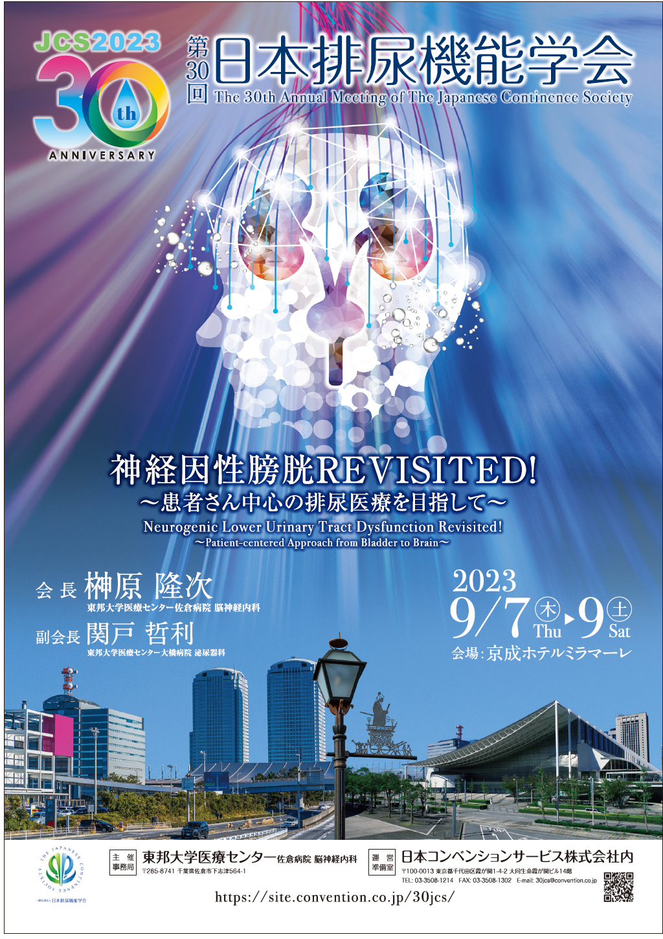

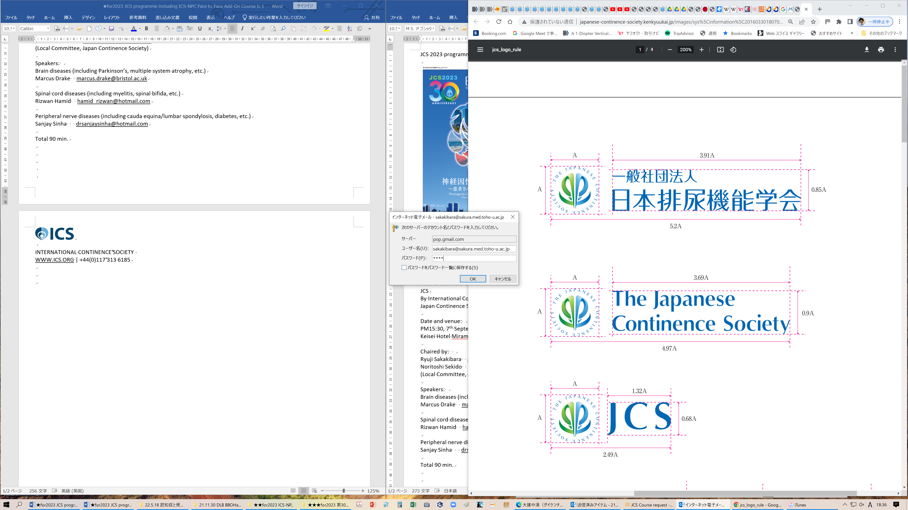 & 
An Update: 2023.3.8
Face to Face Add-On Course: When urologists suspect neurourologic diseases? A joint educational course by ICS-NPC and JCS
By International Continence Society, Neuourology Promotion Committee (ICS-NPC) and
Japan Continence Society (JCS, 2023 chaired by Ryuji Sakakibara, taking place at 7-9th September, 2023)

Date and venue:
PM15:50, 8th (Friday) September, 2023
Keisei Hotel Miramare, Chiba, Japan

Chaired by: Ryuji Sakakibara and Noritoshi Sekido
(Local Committee, Japan Continence Society)

Speakers:
Brain diseases (including Parkinson’s, multiple system atrophy, etc.)
Marcus Drake
Spinal cord diseases (including myelitis, spinal bifida, etc.)
Peripheral nerve diseases (including cauda equina/lumbar spondylosis, diabetes, etc.)
Sanjay Sinha
Total 90 min.

Looking forward to seeing you soon! Best wishes,
Ryuji Sakakibara, Noritoshi Sekido

