DRAFT 19 AUGUST 2017
Co-authors: please provide information here.
Notes for edits to be added later.
AN INTERNATIONAL CONTINENCE
SOCIETY (ICS) REPORT ON THE TERMINOLOGY
FOR SINGLE USE BODYWORN ABSORBENT
INCONTINENCE PRODUCTS
Alan Cottenden**, Mandy Fader**, Chris Chatterton*, Pierre Conrath*,
Helena Engqvist*, Sharon Eustice*, Hakan Leander*, Diane Newman*,
Joan Ostaszkiewicz*, Mary Palmer*, Tara Wilson* and Bernie Haylen⁺
* Member Working Group; ** Co-chair Working Group; ⁺ Chair Standardisation Steering Committee
Mandy Fader, University of Southampton, Southampton, England. m.fader@soton.ac.uk
Alan Cottenden, University College London, London, England. a.cottenden@ucl.ac.uk
Chris Chatterton, designation, England. chrstphrcht@aol.com
Pierre Conrath, EDANA, Brussels, Belgium. pierre.conrath@edana.org
Helena Engqvist, designation, Sweden. helena@engqvistconsulting.com
Sharon Eustice, Cornwall Partnership NHS Foundation Trust, England. Sharon.Eustice@pch-cic.nhs.uk
Hakan Leander, designation, Sweden. hakan@hakle.se
Diane Newman, University of Pennsylvania, Philadelphia, U.S.A. Diane.Newman@uphs.upenn.edu
Joan Ostaszkiewicz, Deakin University, Australia. joan.ostaszkiewicz@deakin.edu.au
Mary Palmer, University of North Carolina at Chapel Hill, Chapel Hil, U.S.A. mhpalmer@email.unc.edu
Tara Wilson, designation, England. tara@willsonfamily.co.uk
Bernard Haylen, University of New South Wales, Sydney. Australia. bernard@haylen.co

Correspondence to:
Prof Mandy Fader,
Faculty of Health Sciences, Ph: (023) 8059 6677
Building 67, Highfield Campus
University of Southampton
Southampton, SO17 1BJ

ABSTRACT

Introduction: to come. Follow outline in POP paper for additional paragraphs
Methods: to come.
Results: to come.
Conclusion: to come.

WORDS (Abstract) XXX
(Introduction-Section 2) XXX
(Appendix) XXX

FIGURES (Introduction-Section 8) XXX
(Appendix) XXX

DISCLOSURES:
Mandy Fader: Disclosures?
Alan Cottenden: Research grant SCA; Student grant: BASF, SCA, Simavita; Lecture honorarium: Astellas.
Chris Chatterton: Disclosures?
Pierre Conrath: Disclosures?
Helena Engqvist: Disclosures?
Sharon Eustice: Disclosures?
Hakan Leander: Disclosures?
Diane Newman: Disclosures?
Joan Ostaszkiewicz: Disclosures?
Mary Palmer: Disclosures?
Tara Wilson: Disclosures?
Bernard Haylen: No Disclosures

INTRODUCTION:
Single use (as opposed to reusable / washable) bodyworn (as opposed to bed and chair protectors) absorbent incontinence products (as opposed to mechanical devices that aim to prevent leakage of urine or faeces, or products such as catheters and sheaths that seek to channel leakage to a receptacle) come in a variety of different designs, but the names used to describe them and their design features sometimes vary a lot between - and even within - countries. It would be much easier for all concerned if the terminology was standardised, providing preferred terms that all are encouraged to use. To that end, the ICS appointed an international working group to consult widely across the international community of people concerned with these products (for example, users, caregivers, clinicians and manufacturers) to establish a standard terminology that enjoys widespread support.

Drawing on their collective experience, the working group created an online questionnaire (See Appendix A) to solicit the opinions of stakeholders internationally. Jenny Ellis and Dominic Turner ran the questionnaire on the Doodlepoll platform, and encouraged ICS members to participate, as well as contacting a variety of clinical, academic and industry organisations known to the ICS whose members might be interested in the work, with a request to encourage their respective members to participate. The questionnaire invited respondents to:

- Express their preferences for a range of offered alternative names for each of 7 different categories of single use bodyworn absorbent incontinence products; suggest any other alternative names worthy of consideration; and explain the reasoning behind their answers.
- Comment on proposed descriptions for the defining features and main variant features for each of the 7 design categories.
- Suggest any additional (to the 7 offered) categories of single use bodyworn absorbent incontinence products that should be included in the proposed standard.
- Comment on proposed definitions for a range of key design features of products (such as absorbent core and leg cuffs) and suggest any additional features that should be included in the proposed standard.
- Suggest (with reasons) a better name for single use bodyworn absorbent incontinence products.
- Identify their interest in these products (such as product user, healthcare professional or product manufacturer) and their nationality.

The questionnaire was finalized and made “live” on 12 December 2016, and closed on 7
March 2017. A hundred people from 18 countries filled out the questionnaire and their nationalities and interests are summarised in Appendix B.

SECTION 1: PREFERRED TERMS FOR PRODUCT DESIGN CATEGORIES
Single use bodyworn absorbent products can be divided into seven distinct categories
according to their main (defining) features. A preferred name for each design category
is proposed below, along with descriptions of their defining - and main variant – features.

Design category 1: Pad
We propose that a product of the kind shown in Figure 1 should be called a pad. The defining features of a pad and the main variant features are described in Table 1.

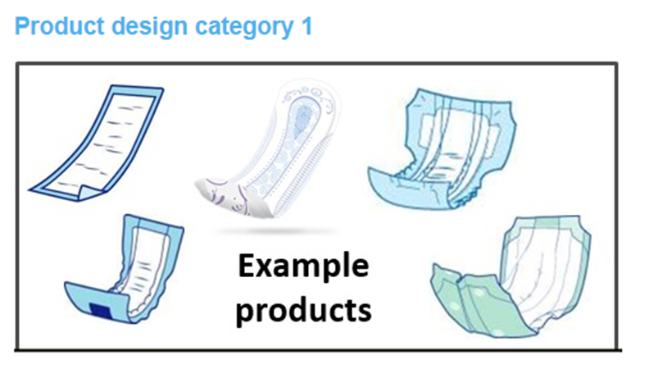
Figure 1: Examples of pads.

Although the online questionnaire found clear international consensus in favour of pad, two alternative names (insert and liner) were popular in some countries, but never more popular than pad (Appendix C, Fig C-1 and Table C-1). Accordingly, use of these two terms – and others favoured by small minorities - is discouraged.

Table 1: The defining features and main variant features of pads.
Defining features | A waterproof-backed absorbent product that is held in place using separate, close-fitting (regular or specially designed) underwear.
Main variant features | - Products may be used by either sex, but some are intended (by their colour, style, shape or the placing of absorbent material, for example) just for men or just for women.  - Products come with different absorption capacities.  - Longitudinal elastic side barriers and leg cuffs on either side of the crotch may be included to improve fit, comfort and prevent leakage.  - Products may have an adhesive strip on the back or adhesive wings to the sides to help secure them in underwear.  - Products may have a wetness indicator.  - Products may or may not be suitable for containing FI as well as UI.

Design category 2: Booster pad
We propose that a product of the kind shown in Figure 2 should be called a booster pad. The defining features of a booster pad and the main variant features are described in Table 2.
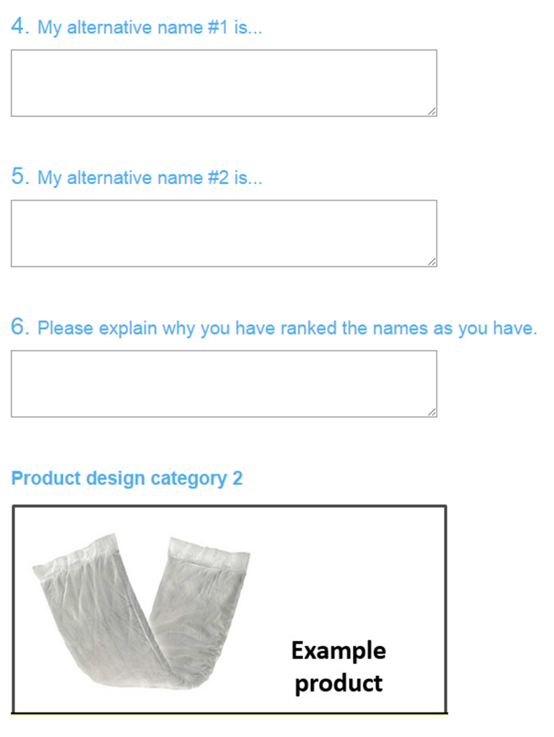
Figure 2: An example of a booster pad.

The online questionnaire found clear international consensus in favour of booster pad. Unbacked pad was a popular alternative in some countries but it was less popular than booster pad in all countries except one (UK) (Appendix C, Fig C-2 and Table C-2). Accordingly, the use of the term unbacked pad is discouraged.

Table 2: The defining features and main variant features of booster pads.
Defining features | An absorbent product without a waterproof backing used (i) inside another products such as a category 6 product to boost its absorption capacity or (ii) on its own, secured using separate, close-fitting, underwear which itself includes waterproofing in the pad area.
Main variant features | - Products may be used by either sex.  - Products may be rectangular or contoured to fit the wearer better.  - Products come with different absorption capacities.  - Products may or may not be suitable for containing FI as well as UI.

Design category 3: Male pad
We propose that a product of the kind shown in Figure 3 should be called a male pad. The defining features of a male pad and the main variant features are described in Table 3.
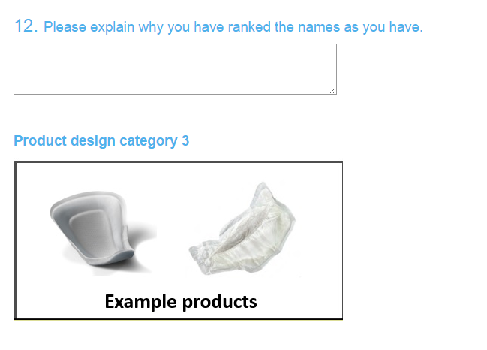
Figure 3: Examples of male pads.

The online questionnaire found clear international consensus in favour of male pad. Guard pad was quite a popular alternative in some countries but it was more popular than male pad in only one (Canada), but only marginally (Appendix C, Fig C-3 and Table C-3). Accordingly, the use of the term guard pad for men - and others favoured by small minorities - is discouraged.

Table 3: The defining features and main variant features of male pads.
Defining features | A waterproof-backed absorbent product for men that is designed to be worn against the penis, and is held in place using separate, close-fitting (regular or specially designed) underwear.
Main variant features | - Products come with different absorption capacities.  - Longitudinal elastic side barriers and leg cuffs at the sides may be included to improve fit and comfort and prevent leakage.  - Products may have an adhesive strip on the back to help secure them in underwear.

Design category 4: Pouch
We propose that a product of the kind shown in Figure 4 should be called a pouch. The defining features of a pouch and the main variant features are described in Table 4.

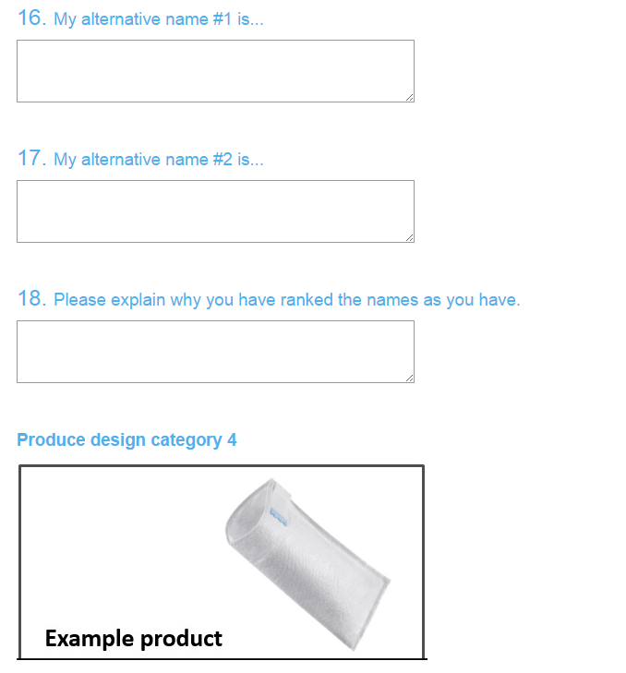
Figure 4: An examples of a pouch.

The online questionnaire found clear international consensus in favour of pouch and no other term emerged as a popular alternative (Appendix C, Fig C-4 and Table C-4).
Table 4: The defining features and main variant features of pouches.
Defining features | A waterproof-backed absorbent product for men, fashioned into a pocket into which the penis – and sometimes the scrotum, too – is placed. They are held in place using separate, close-fitting (regular or specially designed) underwear.
Main variant features | - Products come with different absorption capacities.  - Products may have an adhesive strip on the back to help secure them in underwear.  - Products may have a hook and loop fastening system or adhesive tape to secure the product round the penis.

Design category 5: Protective underwear
We propose that products of the kind shown in Figure 5 should be called protective underwear. The defining features of protective underwear and the main variant features are described in Table 5.

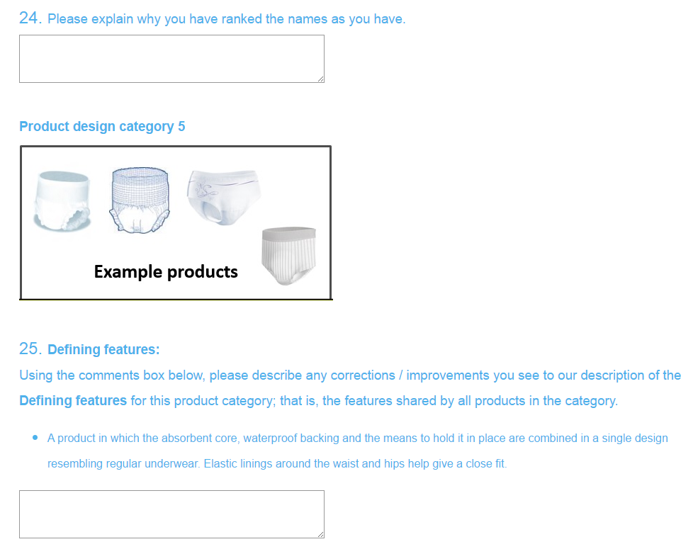
Figure 5: Examples of protective underwear.

The terms protective underwear and pull-up were each supported by about the same number of respondents but protective underwear was favoured over pull-up (or equal to it) in all countries except UK and Ireland (Appendix C, Fig C-5 and Table C-5). Accordingly, the use of the term pull-up - and others favoured by small minorities - is discouraged.
Table 5: The defining features and main variant features of protective underwear.
Defining features | A product in which the absorbent core, waterproof backing and the means to hold it in place are combined in a single design resembling regular underwear. Elastic linings around the waist and hips help give a close fit.
Main variant features | - Products may be used by either sex, but some are intended (by their colour, style or the placing of absorbent material, for example) just for men or just for women.  - Products come with different absorption capacities, and to fit different body sizes.  - Longitudinal elastic side barriers and leg cuffs on either side of the crotch may be included to improve fit and comfort and prevent leakage.  - In some designs, side seams can be torn away for easy removal.  - Products may have wetness indicators  - Products may or may not be suitable for containing FI as well as UI.

Design category 6: All-in-one
We propose that a product of the kind shown in Figure 6 should be called an all-in-one. The defining features of an all-in-one and the main variant features are described in Table 6.

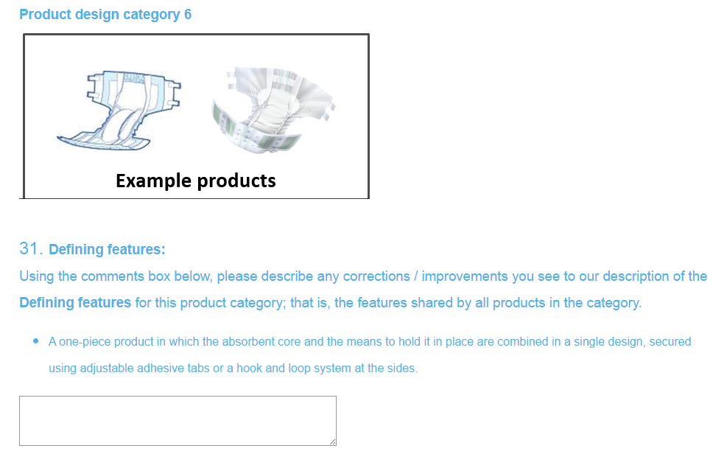
Figure 6: Examples of all-in-ones.

The online questionnaire revealed a diversity of views on what category 6 products should be called. Four countries favoured diaper, but many respondents were against the term because if its infant connotations. Slip and wrap-around were favoured in the Netherlands but enjoyed little support elsewhere. Adult brief was favoured by Canada, USA and Norway but, again, there was little support elsewhere. All-in-one was favoured by Australia, Belgium and the UK and had the highest number of respondents favouring it (but the UK was strongly represented: about a third of respondents) (Appendix C, Fig C-6 and Table C-6). In conclusion, we recommend that these products should be called all-in-ones. However, adult brief should be allowed in parentheses (eg “… all-in-one (sometime known as adult briefs)…”.

Table 6: The defining features and main variant features of all-in-ones.
Defining features | A one-piece product in which the absorbent core and the means to hold it in place are combined in a single design, secured using adjustable adhesive tabs or a hook and loop fastening system at the sides.
Main variant features | - Products may be used by either sex, but some are intended (by their colour, style or the placing of absorbent material, for example) just for men or just for women.  - Products come with different absorption capacities, and to fit different body sizes.  - Longitudinal elastic side barriers and leg cuffs on either side of the crotch may be included to improve fit and comfort and prevent leakage.  - Products may have wetness indicators.  - Products may or may not be suitable for containing FI as well as UI.

Design category 7: Belted product
We propose that a product of the kind shown in Figure 7 should be called a belted product. The defining features of a belted product and the main variant features are described in Table 7.

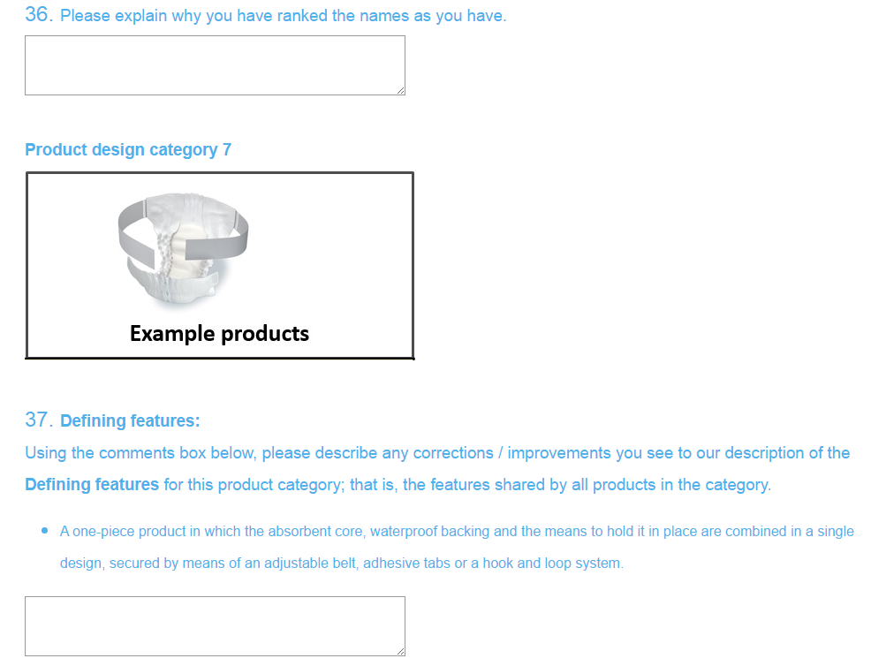
Figure 7: Example of a belted product.

The online questionnaire found clear international consensus in favour of belted product. This was the (joint) top choice in most countries. Denmark, Italy and Sweden favoured flex – a term also popular in the Netherlands - but this was discounted as it is a brand name (Appendix C, Fig C-7 and Table C-7).

Table 7: The defining features and main variant features of belted products.
Defining features | A one-piece product in which the absorbent core, waterproof backing and the means to hold it in place are combined in a single design, secured by means of an adjustable belt, adhesive tabs or a hook and loop fastening system.
Main variant features | - Products may be used by either sex, but some are intended (by their colour, style or the placing of absorbent material, for example) just for men or just for women.  - Products come with different absorption capacities, and to fit different body sizes.  - Longitudinal elastic side barriers and leg cuffs on either side of the crotch may be included to improve fit and comfort and prevent leakage.  - Products may have wetness indicators.  - Products may or may not be suitable for containing FI as well as UI.

SECTION 2: PREFERRED TERMS FOR PRODUCT DESIGN FEATURES
This section provides explanations and definitions for the design features most commonly
found in single use bodyworn absorbent incontinence products, and they should be read in conjunction with Figure 8.
The Topsheet in an absorbent incontinence pad is the layer of fabric which lies against the
wearer's skin. It is made from a water-permeable material that allows urine to pass readily
through to the acquisition and distribution layer and the absorbent core beneath.

Absorbent incontinence products often have an Acquisition and Distribution Layer (ADL)
between the topsheet (above) and the absorbent core (below). The ADL is designed to allow
urine to enter the pad readily, and spread it over a large area of absorbent core. It does not,
itself, absorb urine.
The Absorbent core of an absorbent incontinence product is where urine is captured and
stored. It is made from (a) material(s) which absorb(s) urine readily and retains it under
pressure, such as when the wearer changes posture or position.

The Backsheet in an absorbent incontinence product is a layer of water-proof material which
forms the outside surface of the pad, away from the wearer's body. It may be breathable.

Figure 8: Diagrams of example bodyworn absorbent incontinence products to show their various design features.
Fasteners (Tabs) enable the front and back regions of all-in-one and belted products to
be secured to one another, helping to hold the product in the intended shape and enable a
close fit to the wearer. Fasteners / tabs are most commonly faced with an adhesive (which
usually allows them to be undone and refastened to achieve the desired fit) or a hook and
loop fastening system.

Elastication is often used to give an incontinence pad the desired shape and to
achieve a close fit with the wearer. It is commonly used in the waist belts of all-in-ones,
protective underwear and belted products. In protective underwear it may be used
across much of the area of the product. It is used along the edges of the crotch region in many
different designs.

Leg cuffs refer to a particular kind of elastication which may be used longitudinally on
a product near the edges of the crotch region to promote close contact with the groin on either
side of the body.

ACKNOWLEDGEMENTS
We are pleased to acknowledge Jenny Ellis’ excellent work in administering the project and – with Dominic Turner – creating a viable on-line questionnaire. We are grateful, too, to Helena Engqvist who gathered all the diagrams and much of the written content for the questionnaire. The working group had no virtual or physical meetings but – by email - contributed actively to the editing of numerous drafts of questionnaire and reports.
Acknowledge reviewers in due course.

REFERENCES
I don’t think we have any, do we?
APPENDIX A; The online questionnaire used to gather views.

International Continence Society Standardisation of Terminology for Single use Body worn Absorbent Incontinence Products
Single use body worn absorbent incontinence products come in a variety of different designs but the names used to describe them - and their design features – sometimes vary a lot between and even within countries. It would be much easier for all concerned if the terminology was standardised, providing preferred terms that we are all encouraged to use. To that end, the ICS has appointed an international working group to consult widely across the international community of people concerned with these products (for example, users, caregivers, clinicians and manufacturers) to establish a standard terminology that enjoys widespread support.
Our first step – as the working group – was to create a first draft based on our collective knowledge and experience and we are now seeking comment on it from as wide a range of stakeholders and parts of the world as possible. Please contribute your views by filling out the questionnaire below. We would also appreciate it if you would publicise the project and questionnaire among your network of any contacts you think may also have a view to offer, encouraging them to fill out the questionnaire, too.
Once we have heard from a wide range of stakeholders internationally, we will review the comments and edit the document. If the changes need to be extensive we will circulate the revised version for further comment. Ultimately, the plan is to publish and publicise it via ICS channels.
Many thanks
The ICS Working Group for Standardisation of Terminology for Single Use Body Worn Absorbent Incontinence Products

I. Names for the different design categories of single use body worn absorbent incontinence products
We think that all single use body worn absorbent incontinence products can be divided into the seven different categories described below. Please use the following questions to give us your views on the different names that are used - and that you think should or should not be used - for the products in each category, and comment on our descriptions of their defining and variant features.
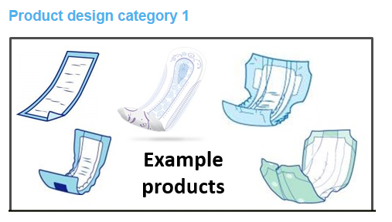
Defining features:
Using the comments box below, please describe any corrections / improvements you see to our description of the Defining features for this product category; that is, the features shared by all products in the category.
- A waterproof-backed absorbent product that is held in place using separate, close-fitting (regular or specially designed) underwear.

Main variant features:
Using the comments box below, please describe any corrections / improvements you see to our description of the Main variant features for this category; that is, features that may or may not be present, or may come in different forms.
- Products may be used by either sex, but some are intended (by their colour , style or the placing of absorbent material, for example) just for men or just for women.
- Products come with different absorption capacities.
- Longitudinal elastic side barriers and leg cuffs on either side of the crotch may be included to improve fit, comfort and prevent leakage.
- Products may have an adhesive strip on the back or adhesive wings to the sides to help secure them in underwear.
The table below lists all the different names that we know are currently used for the products in this design category. If you know of others, please tell us up to two additional names in the comments boxes below the table (My alternative name #1 and My alternative name #2). Then taking all the names we have listed in the table below - and any alternative names you have added in the comments boxes - please rank them in order of preference by putting a 1 next to the one you think best, a 2 next to your second choice and so on, until you have ranked all the names you think have some merit. If there are any names you think shouldn't be used at all, don’t assign a rank number to them.
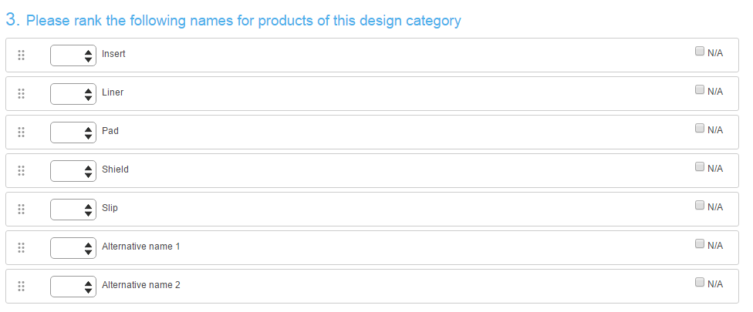
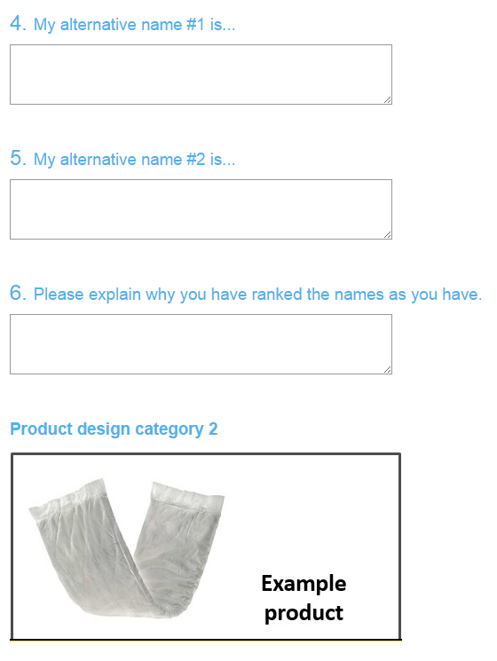~
Defining features:
Using the comments box below, please describe any corrections / improvements you see to our description of the Defining features for this product category; that is, the features shared by all products in the category.
- An absorbent product without a waterproof backing used (i) inside another products such as a category 6 product to boost its absorption capacity or (ii) on its own, secured using separate, close-fitting, underwear which itself includes waterproofing in the pad area.
8. Main variant features:
Using the comments box below, please describe any corrections / improvements you see to our description of the Main variant features for this category; that is, features that may or may not be present, or may come in different forms.
- Products may be used by either sex.
- Products may be rectangular or contoured to fit the wearer better.
Products come with different absorption capacities.
The table below lists all the different names that we know are currently used for the products in this design category. If you know of others, please tell us up to two additional names in the comments boxes below the table (My alternative name #1 and My alternative name #2). Then taking all the names we have listed in the table below - and any alternative names you have added in the comments boxes - please rank them in order of preference by putting a 1 next to the one you think best, a 2 next to your second choice and so on, until you have ranked all the names you think have some merit. If there are any names you think shouldn't be used at all, don’t assign a rank number to them.
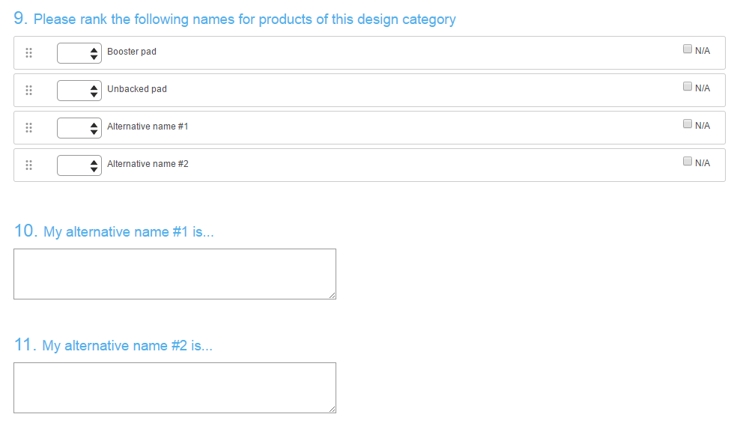
13. Defining features:
Using the comments box below, please describe any corrections / improvements you see to our description of the Defining features for this product category; that is, the features shared by all products in the category.
- A waterproof-backed absorbent product for men that is designed to be worn against the penis, and is held in place using separate, close-fitting (regular or specially designed) underwear.
14. Main variant features:
- Using the comments box below, please describe any corrections / improvements you see to our description of the Main variant features for this category; that is, features that may or may not be present, or may come in different forms.
- Products come with different absorption capacities.
- Longitudinal elastic side barriers and leg cuffs at the sides may be included to improve fit and comfort and prevent leakage.
- Products may have an adhesive strip on the back to help secure them in underwear.
The table below lists all the different names that we know are currently used for the products in this design category. If you know of others, please tell us up to two additional names in the comments boxes below the table (My alternative name #1 and My alternative name #2). Then taking all the names we have listed in the table below - and any alternative names you have added in the comments boxes - please rank them in order of preference by putting a 1 next to the one you think best, a 2 next to your second choice and so on, until you have ranked all the names you think have some merit. If there are any names you think shouldn't be used at all, don’t assign a rank number to them.
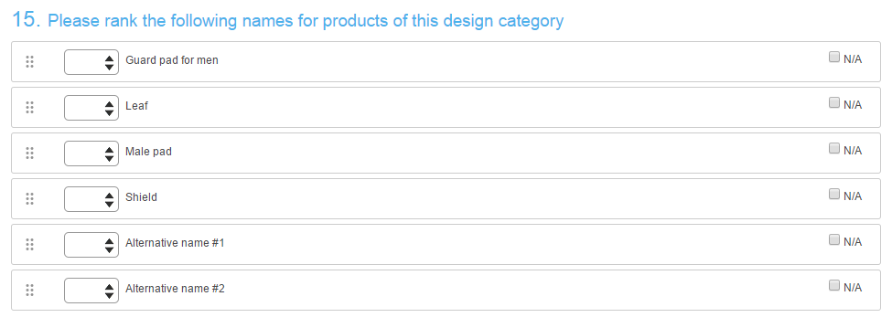
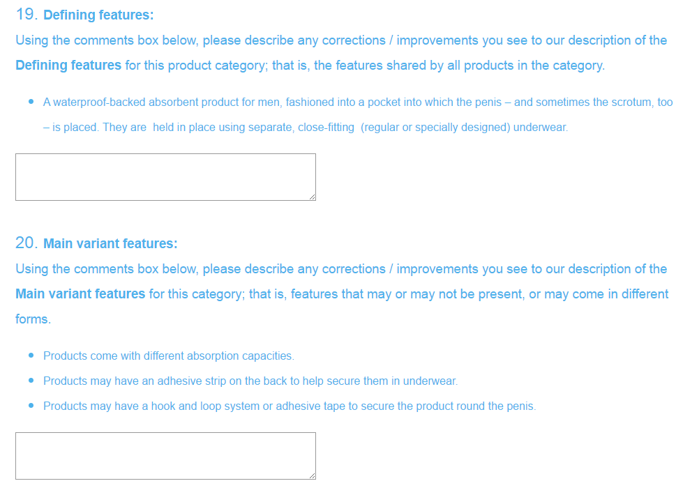
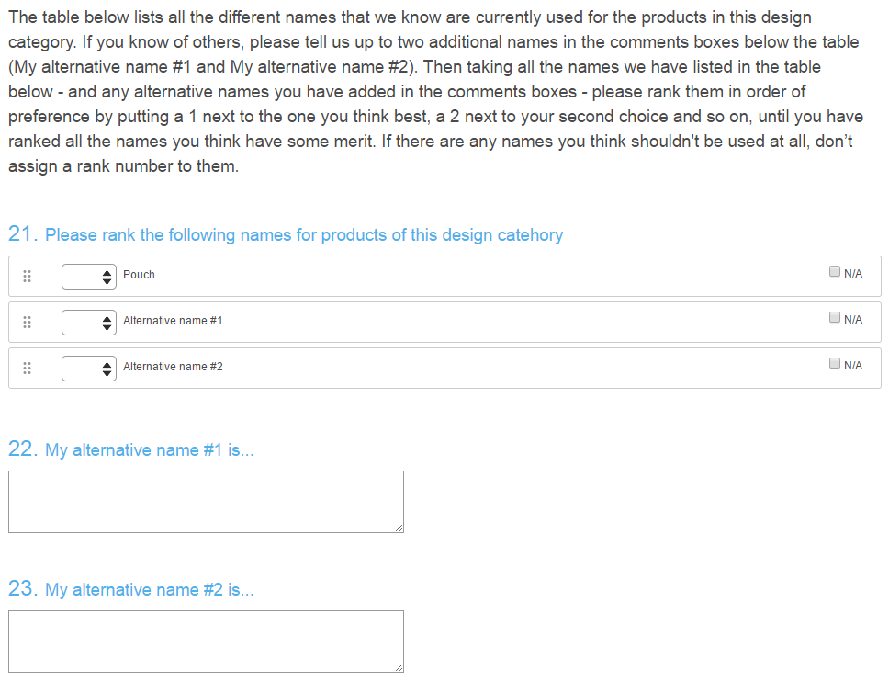
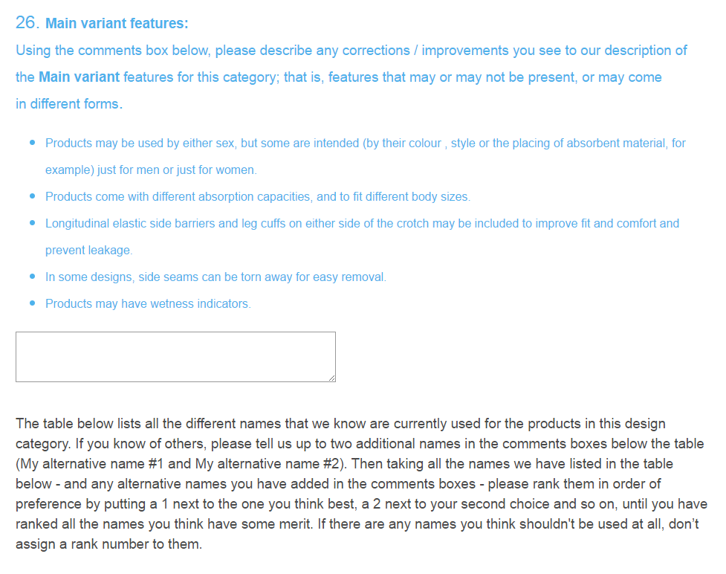
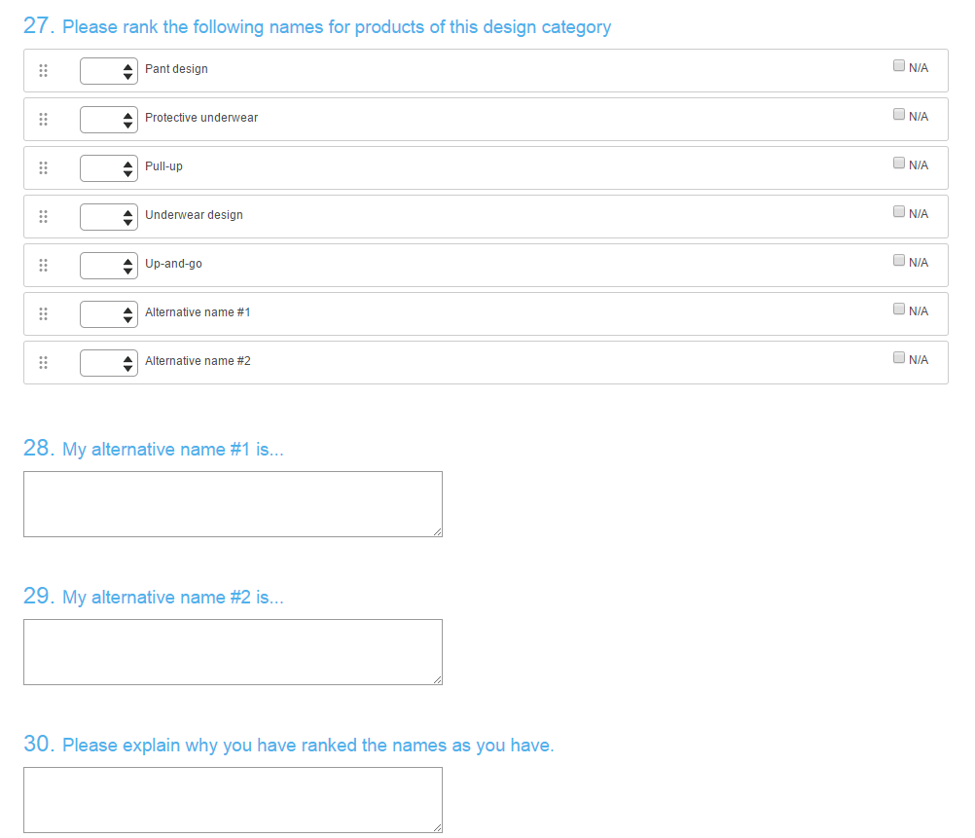
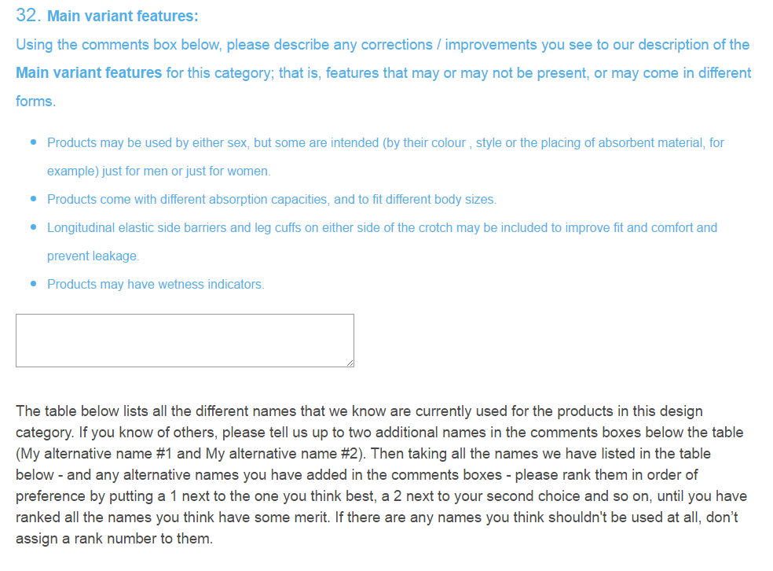
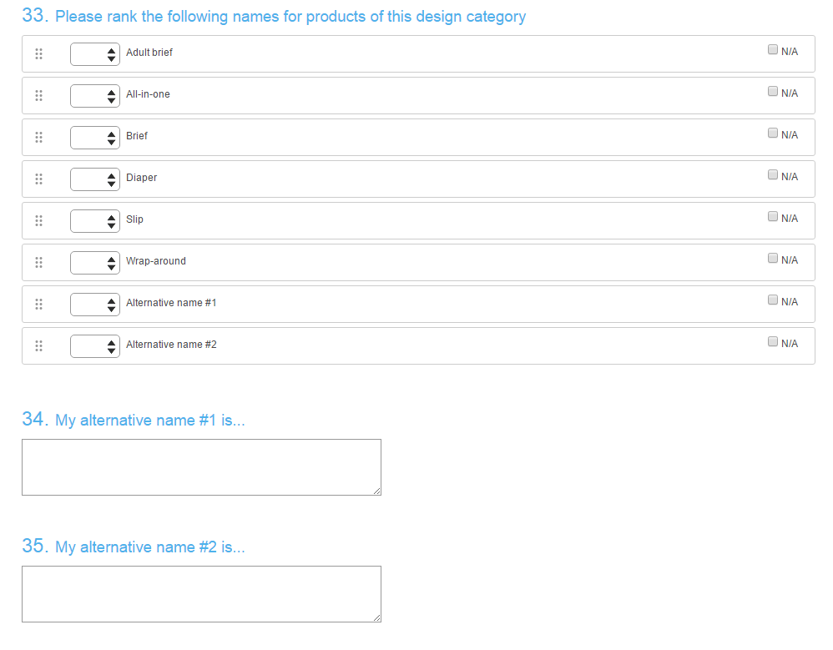
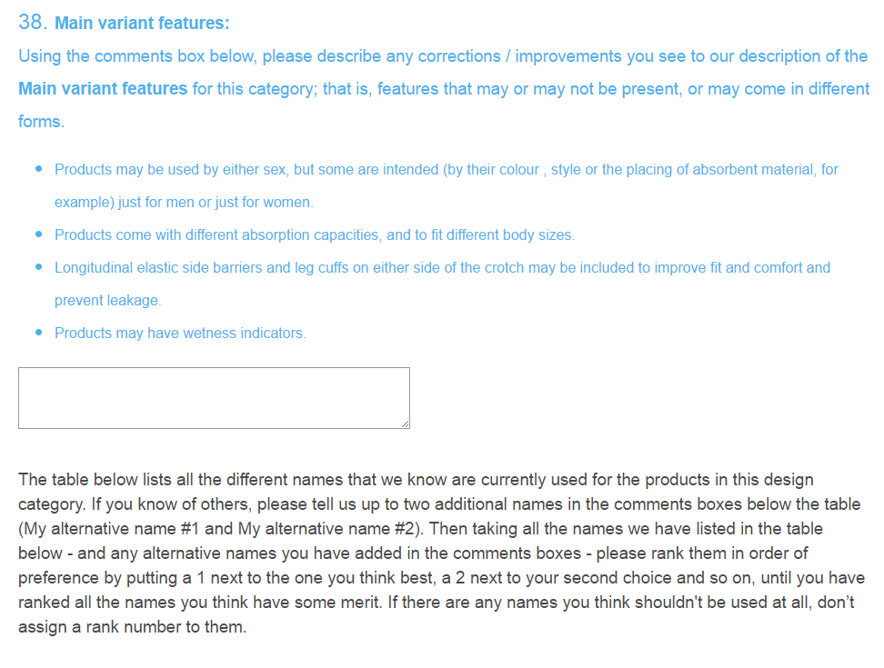
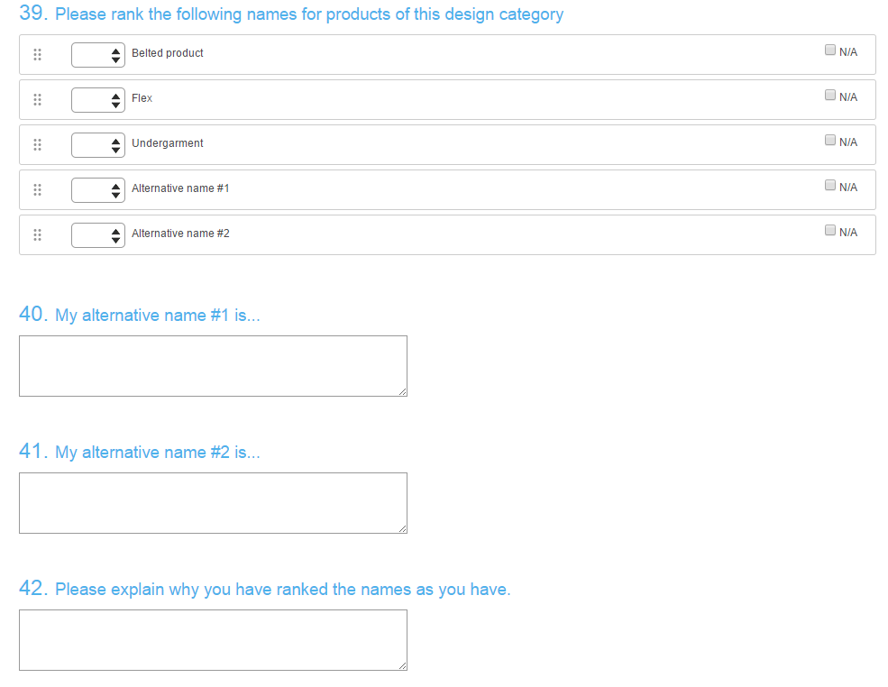
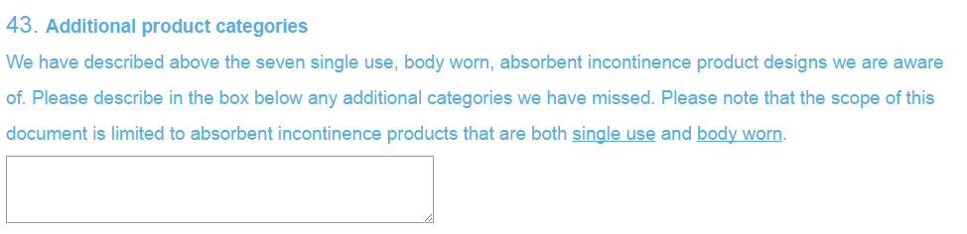
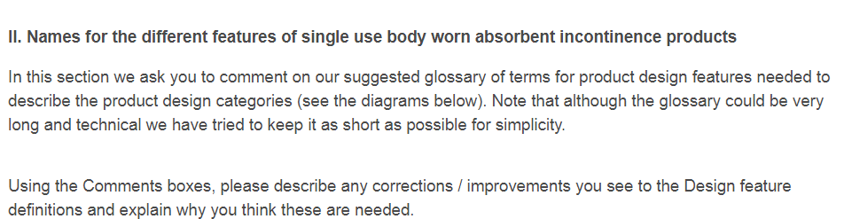
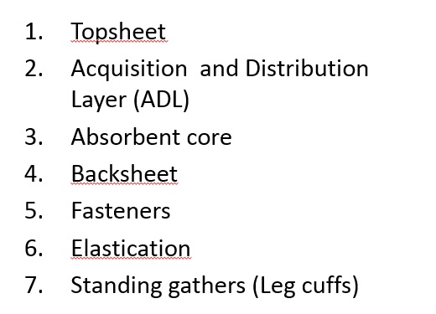
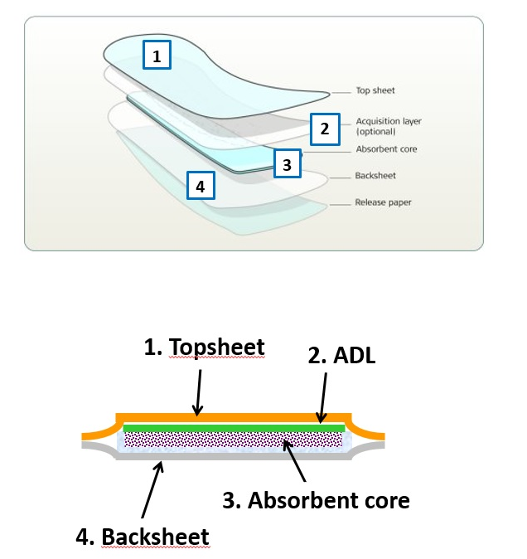

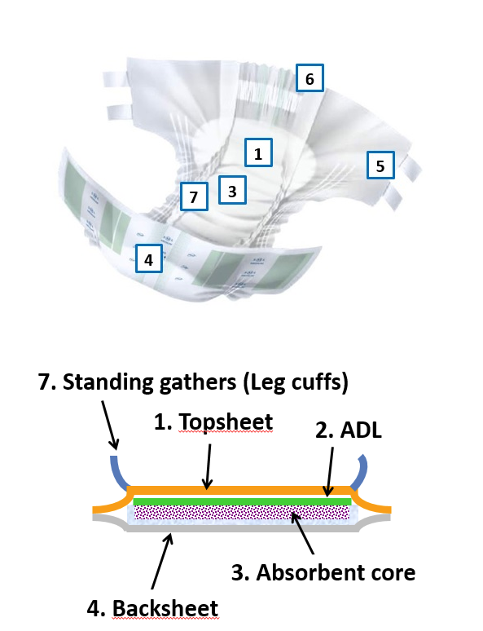
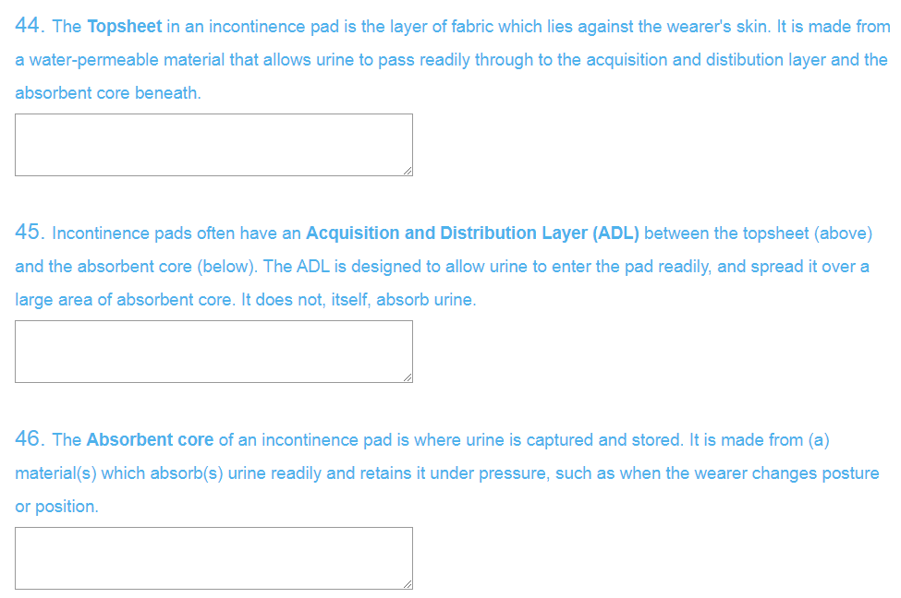
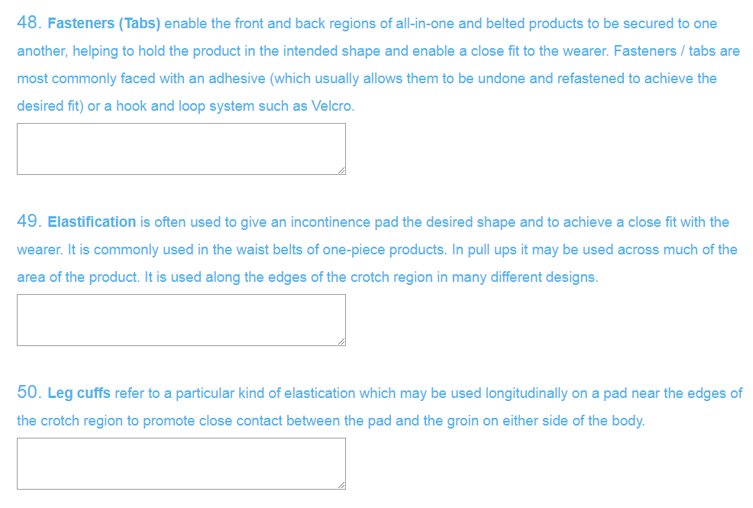
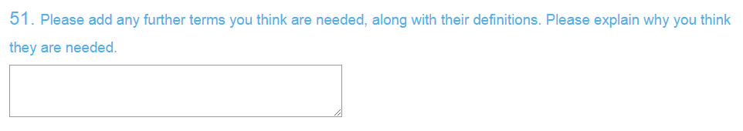
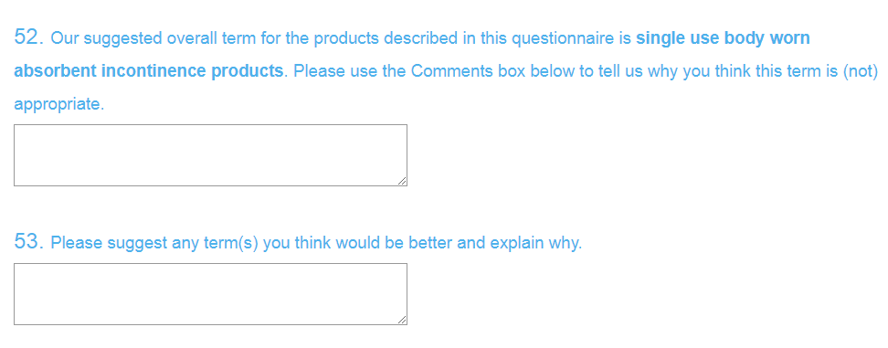
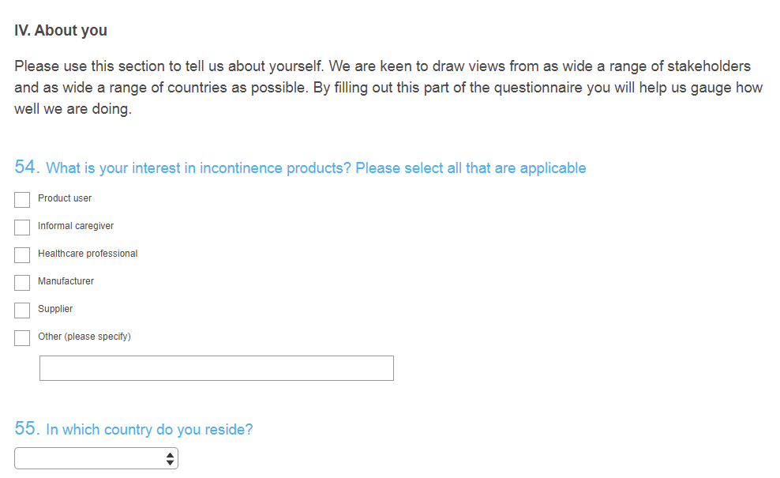
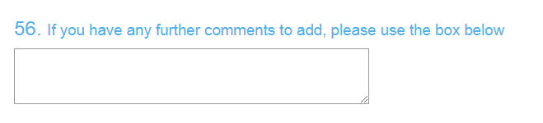


APPENDIX B: Characteristics of the questionnaire respondents

The questionnaire was filled out by a total of 100 respondents. Of the 88 who declared their interest in incontinence products, most (64.8%) identified themselves as healthcare professionals (Table B-1) There were smaller groups of manufacturers, suppliers, product users and informal caregivers. Seven respondents declared two interests (eg both supplier and product user), while three claimed three interests.

Role: | Product user | Informal caregiver | Healthcare professional | Manufacturer | Supplier | Other (please specify) | Undeclared | All
Totals: | 10 | 4 | 57 | 16 | 4 | 13 | 12 | 100
%: | 11.4 | 4.5 | 64.8 | 18.2 | 4.5 | 14.8 | 13.6

Table B-1: Responses to Q54 (Appendix A): What is your interest in incontinence products?

Almost a third (32.2%) of respondents who declared their nationality were from the UK and about a further third (34.5%) were from other English-speaking countries (Table B-2). Two-thirds (67.8%) lived in Europe; around a quarter (23%) in North America; and 9.2% in Australasia.

Nationality | Number |  | Nationality | Number
Australia | 6 |  | Japan | 1
Belgium | 4 |  | Netherlands | 8
Canada | 10 |  | New Zealand | 1
Czech Republic | 1 |  | Norway | 2
Denmark | 3 |  | Portugal | 1
Finland | 1 |  | Spain | 1
Germany | 1 |  | Sweden | 4
Ireland | 3 |  | United Kingdom | 28
Italy | 2 |  | United States | 10
 |  |  | Undeclared | 13

Table B-2: Responses to Q55 (Appendix A): In which country do you reside?

APPENDIX C: Key findings from the on-line questionnaire

Fig C-1: Ranking of names for Category 1 products (see Question 3, Appendix A; N=95). Alt1 and Alt2 refer to the first and second alternative names offered by some respondents, and those names generally varied between respondents.

Table C-1: The number of respondents of each nationality who ranked a given name as either their first or second choice for Category 1 products (See Question 3, Appendix A; N=95). Yellow shows the highest number(s) in each row; that is, gives a rough indication of national preference. NB alternative names (Alt 1 and Alt 2) generally varied between respondents.
Country | Names for design category #1
Country | Insert | Liner | Pad | Shield | Slip | Alt 1 | Alt 2
Australia | 1 | 2 | 6 | 3 | 0 | 0 | 0
Belgium | 3 | 1 | 4 | 0 | 0 | 0 | 0
Canada | 3 | 5 | 9 | 1 | 0 | 1 | 0
Czech Republic | 0 | 0 | 0 | 0 | 0 | 1 | 0
Denmark | 0 | 0 | 0 | 0 | 0 | 2 | 0
Finland | 0 | 0 | 0 | 0 | 0 | 1 | 0
Germany | 0 | 0 | 1 | 0 | 1 | 0 | 0
Ireland | 1 | 2 | 2 | 0 | 1 | 0 | 0
Italy | 1 | 0 | 0 | 0 | 0 | 1 | 0
Japan | 1 | 0 | 1 | 0 | 0 | 0 | 0
Netherlands | 5 | 2 | 5 | 0 | 0 | 3 | 0
New Zealand | 1 | 0 | 1 | 0 | 0 | 0 | 0
Norway | 1 | 0 | 2 | 1 | 0 | 0 | 0
Spain | 0 | 0 | 0 | 0 | 0 | 0 | 0
Sweden | 0 | 0 | 0 | 0 | 0 | 2 | 0
United Kingdom | 11 | 8 | 14 | 1 | 3 | 5 | 1
United States | 1 | 2 | 3 | 1 | 0 | 1 | 1
Unknown | 4 | 6 | 3 | 1 | 2 | 0 | 0
All | 33 | 28 | 51 | 8 | 7 | 17 | 2

Fig C-2: Ranking of names for Category 2 products (see Question 9, Appendix A; N=80). Alt1 and Alt2 refer to the first and second alternative names offered by some respondents, and those names generally varied between respondents.

Table C-2: The number of respondents of each nationality who ranked a given name as either their first or second choice for Category 2 products (See Question 9, Appendix A; N=80). Yellow shows the highest number(s) in each row; that is, gives a rough indication of national preference. NB alternative names (Alt 1 and Alt 2) generally varied between respondents.
Country | Names for design category #2
Country | Booster pad | Unbacked pad | Alt 1 | Alt 2
Australia | 6 | 3 | 3 | 0
Belgium | 4 | 1 | 2 | 0
Canada | 8 | 6 | 3 | 0
Czech Republic | 0 | 0 | 1 | 0
Denmark | 0 | 0 | 2 | 0
Finland | 0 | 0 | 1 | 0
Germany | 1 | 1 | 0 | 0
Ireland | 2 | 0 | 2 | 0
Italy | 1 | 0 | 1 | 0
Japan | 1 | 0 | 0 | 0
Netherlands | 4 | 3 | 4 | 0
New Zealand | 1 | 1 | 0 | 0
Norway | 1 | 1 | 0 | 0
Spain | 0 | 0 | 0 | 0
Sweden | 0 | 0 | 2 | 0
United Kingdom | 12 | 15 | 8 | 1
United States | 4 | 2 | 2 | 0
Unknown | 3 | 2 | 2 | 1
All | 48 | 35 | 33 | 2

Fig C-3: Ranking of names for Category 3 products (see Question 15, Appendix A; N=89). Alt1 and Alt2 refer to the first and second alternative names offered by some respondents, and those names generally varied between respondents.

Table C-3: The number of respondents of each nationality who ranked a given name as either their first or second choice for Category 3 products (See Question 15, Appendix A; N=89). Yellow shows the highest number(s) in each row; that is, gives a rough indication of national preference.

Country | Names for design category #3
Country | Guard pad for men | Leaf | Male pad | Shield | Alt 1 | Alt 2
Australia | 3 | 0 | 5 | 2 | 2 | 0
Belgium | 1 | 1 | 3 | 1 | 2 | 0
Canada | 8 | 0 | 7 | 4 | 0 | 0
Czech Republic | 0 | 0 | 0 | 0 | 1 | 0
Denmark | 1 | 1 | 0 | 0 | 2 | 0
Finland | 0 | 0 | 0 | 0 | 1 | 0
Germany | 1 | 1 | 0 | 0 | 0 | 0
Ireland | 2 | 0 | 3 | 1 | 0 | 0
Italy | 1 | 0 | 0 | 0 | 1 | 0
Japan | 1 | 0 | 0 | 1 | 0 | 0
Netherlands | 4 | 0 | 6 | 2 | 1 | 0
New Zealand | 1 | 1 | 0 | 0 | 0 | 0
Norway | 2 | 0 | 2 | 0 | 0 | 0
Spain | 0 | 0 | 0 | 0 | 0 | 0
Sweden | 0 | 0 | 0 | 0 | 2 | 0
United Kingdom | 10 | 8 | 14 | 6 | 1 | 0
United States | 3 | 0 | 3 | 2 | 0 | 0
Unknown | 4 | 2 | 2 | 1 | 1 | 0
All | 42 | 14 | 45 | 20 | 14 | 0

Fig C-4: Ranking of names for Category 4 products (see Question 21, Appendix A; N=72). Alt1 and Alt2 refer to the first and second alternative names offered by some respondents, and those names generally varied between respondents.

Table C-4: The number of respondents of each nationality who ranked a given name as either their first or second choice for Category 4 products (See Question 21, Appendix A; N=72). Yellow shows the highest number(s) in each row; that is, gives a rough indication of national preference. NB alternative names (Alt 1 and Alt 2) generally varied between respondents.
Country | Names for design category #4
Country | Pouch | Alt 1 | Alt 2
Australia | 6 | 0 | 0
Belgium | 4 | 1 | 0
Canada | 6 | 4 | 1
Czech Republic | 1 | 0 | 0
Denmark | 2 | 0 | 0
Finland | 1 | 0 | 0
Germany | 0 | 0 | 0
Ireland | 3 | 0 | 1
Italy | 2 | 0 | 0
Japan | 0 | 0 | 0
Netherlands | 6 | 3 | 0
New Zealand | 1 | 0 | 0
Norway | 2 | 0 | 0
Spain | 0 | 0 | 0
Sweden | 2 | 0 | 0
United Kingdom | 17 | 4 | 0
United States | 5 | 1 | 0
Unknown | 3 | 0 | 0
All | 61 | 13 | 2

Fig C-5: Ranking of names for Category 5 products (see Question 27, Appendix A; N=87). Alt1 and Alt2 refer to the first and second alternative names offered by some respondents, and those names generally varied between respondents.

Table C-5: The number of respondents of each nationality who ranked a given name as either their first or second choice for Category 5 products (See Question 27, Appendix A; N=87). Yellow shows the highest number(s) in each row; that is, gives a rough indication of national preference. NB alternative names (Alt 1 and Alt 2) generally varied between respondents.
Country | Names for design category #5
Country | Pant design | Protective underwear | Pull-up | Underwear design | Up-and-go | Alt 1 | Alt 2
Australia | 2 | 4 | 4 | 0 | 0 | 2 | 0
Belgium | 2 | 3 | 2 | 1 | 0 | 0 | 0
Canada | 0 | 8 | 6 | 3 | 0 | 1 | 0
Czech Republic | 0 | 1 | 0 | 0 | 0 | 0 | 0
Denmark | 0 | 2 | 0 | 0 | 0 | 0 | 0
Finland | 1 | 1 | 0 | 0 | 0 | 0 | 0
Germany | 0 | 1 | 0 | 1 | 0 | 0 | 0
Ireland | 0 | 1 | 3 | 0 | 0 | 1 | 0
Italy | 0 | 2 | 0 | 0 | 0 | 0 | 0
Japan | 0 | 0 | 0 | 0 | 0 | 0 | 0
Netherlands | 5 | 4 | 3 | 0 | 0 | 0 | 1
New Zealand | 0 | 0 | 1 | 0 | 0 | 1 | 0
Norway | 1 | 2 | 1 | 0 | 0 | 0 | 0
Spain | 0 | 0 | 0 | 0 | 0 | 0 | 0
Sweden | 0 | 2 | 0 | 0 | 0 | 0 | 0
United Kingdom | 13 | 9 | 19 | 1 | 0 | 2 | 0
United States | 1 | 5 | 4 | 0 | 0 | 1 | 0
Unknown | 2 | 3 | 2 | 0 | 0 | 1 | 0
All | 27 | 48 | 45 | 6 | 0 | 9 | 1

Fig C-6: Ranking of names for Category 6 products (see Question 33, Appendix A; N=76). Alt1 and Alt2 refer to the first and second alternative names offered by some respondents, and those names generally varied between respondents.

Table C-6: The number of respondents of each nationality who ranked a given name as either their first or second choice for Category 6 products (See Question 33, Appendix A; N=76). Yellow shows the highest number(s) in each row; that is, gives a rough indication of national preference. NB alternative names (Alt 1 and Alt 2) generally varied between respondents.
Country | Names for design category #6
Country | Adult brief | All-in-one | Brief | Diaper | Slip | Wrap-around | Alt 1 | Alt 2
Australia | 1 | 6 | 0 | 1 | 1 | 3 | 0 | 0
Belgium | 1 | 2 | 1 | 1 | 1 | 0 | 1 | 0
Canada | 9 | 1 | 8 | 0 | 0 | 1 | 0 | 0
Czech Republic | 0 | 0 | 0 | 0 | 1 | 0 | 0 | 0
Denmark | 0 | 0 | 0 | 0 | 0 | 0 | 0 | 0
Finland | 0 | 0 | 0 | 0 | 0 | 0 | 0 | 0
Germany | 0 | 1 | 0 | 1 | 0 | 0 | 0 | 0
Ireland | 1 | 1 | 1 | 2 | 0 | 0 | 1 | 0
Italy | 0 | 0 | 0 | 0 | 0 | 0 | 0 | 0
Japan | 0 | 0 | 0 | 0 | 0 | 0 | 0 | 0
Netherlands | 1 | 1 | 0 | 4 | 4 | 4 | 0 | 0
New Zealand | 0 | 1 | 0 | 0 | 1 | 0 | 0 | 0
Norway | 2 | 0 | 1 | 1 | 0 | 0 | 0 | 0
Spain | 0 | 0 | 0 | 0 | 0 | 0 | 0 | 0
Sweden | 0 | 0 | 0 | 0 | 0 | 0 | 0 | 0
United Kingdom | 1 | 15 | 1 | 6 | 9 | 6 | 4 | 0
United States | 4 | 0 | 0 | 4 | 0 | 0 | 1 | 0
Unknown | 1 | 4 | 0 | 1 | 1 | 1 | 0 | 1
All | 21 | 32 | 12 | 21 | 18 | 15 | 7 | 1

Fig C-7: Ranking of names for Category 7 products (see Question 39, Appendix A; N=84). Alt1 and Alt2 refer to the first and second alternative names offered by some respondents, and those names generally varied between respondents.

Table C-7: The number of respondents of each nationality who ranked a given name as either their first or second choice for Category 7 products (See Question 39, Appendix A; N=84). Yellow shows the highest number(s) in each row; that is, gives a rough indication of national preference. NB alternative names (Alt 1 and Alt 2) generally varied between respondents.
Country | Names for design category #7
Country | Belted product | Flex | Undergarment | Alt 1 | Alt 2
Australia | 6 | 3 | 1 | 0 | 0
Belgium | 4 | 0 | 0 | 1 | 0
Canada | 10 | 2 | 0 | 3 | 0
Czech Republic | 0 | 1 | 0 | 0 | 0
Denmark | 0 | 2 | 0 | 0 | 0
Finland | 1 | 1 | 0 | 0 | 0
Germany | 1 | 0 | 0 | 0 | 0
Ireland | 3 | 1 | 1 | 0 | 0
Italy | 0 | 2 | 0 | 0 | 0
Japan | 1 | 0 | 0 | 0 | 0
Netherlands | 5 | 5 | 1 | 2 | 0
New Zealand | 1 | 1 | 0 | 0 | 0
Norway | 1 | 1 | 0 | 1 | 0
Spain | 0 | 0 | 0 | 0 | 0
Sweden | 0 | 2 | 0 | 0 | 0
United Kingdom | 22 | 7 | 1 | 3 | 0
United States | 3 | 2 | 2 | 1 | 0
Unknown | 3 | 2 | 0 | 1 | 0
All | 61 | 32 | 6 | 12 | 0

